**inSight 2017**

**Department : Department of Library**

**Problem Title : Library management application**

**Problem Code : PS08**

**Problem Description :**

Library management application is an android application which aims in developing a computerized system to maintain all the daily work of library with a user friendly interface. This project has many features which are generally not available in normal library management systems like facility of user login and teachers login .It also has a facility of admin (librarian) login through which the admin can monitor the whole system .It also has facility of an online notice board where teachers and student can put up information about workshops or seminars being held in our colleges or nearby colleges.

Main features:

* It must contain journals, notes, e-books and previous years question papers that are present in OPAC.
* It must push a notification to the students at the time of book issue.
* It must send alert notification to the student about book submission and overdues.
* Students and teachers must see the books that are issued to them.
* Librarian i.e. admin of this application must search the students and books (book bank as well as normal book) issued to particular students with their issue date.

**Proposed solution:**

Library Management System (LMS) is a web based solution which is developed on latest technology focused towards automating the vital activities of the Library.

The LMS Solution can be integrated with Barcode for easy access and retrieval of any item from the Library. An online public access catalog facility can be provided for speedy retrieval of any kind of document. The LMS solution can be linked with self service KIOSKS for quick search and online requisition.

**Modules:**  
The LMS has a rich set of functionalities that are spread across various modules listed below;

|  |  |
| --- | --- |
|  | Acquisition |
|  | Cataloging |
|  | Circulation |
|  | OPAC |
|  | Serials |
|  | Administration |
|  | Stock Verification |
|  | Inter Library loan |
|  | Accessioning |
|  | Masters |
|  | MIS Reports |
|  | Administration |
|  | There will be three major components :  1. Stock maintenance.  2. Transaction entry.  3. Reports    Proposed system provides with following solutions :  1. It provides "better and efficient" service to members.  2. Reduce the workload of employee.  3. Faster retrieval of information about the desired book.  4. Provide facility for proper monitoring reduce paper work and provide data security.  5. All details will be available on a click. |

**Technology Stack :**

Technology Used :

Operating system –Windows 10 is used as operating system.

Database MYSQL –used to maintain and retriev the records

**HTML, Java script*-*used to write the whole code.**

**Use Case:**

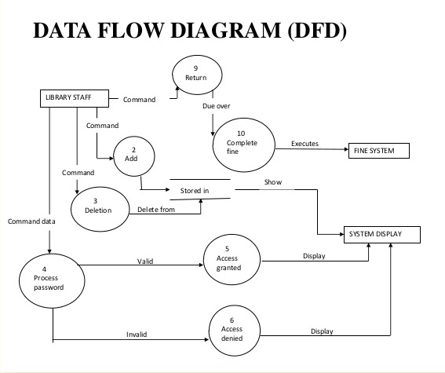

**Team Members details:**

|  |  |  |  |  |
| --- | --- | --- | --- | --- |
| **Role** | **Name** | **USN** | **Email id** | **Phone no.** |
| Team Leader | Varshitha B | 1si15is061 | varshithabv@gmail.com | 7022601431 |
| Team Member 1 | Kshama Jain B | 1si15is025 | Kshama.jain2797@gmal.com | 8867858575 |
| Team Member 2 |  |  |  |  |